**K9Go**

Created by KendraLynn

**Description:**

I am developing an app that aims to assist dog owners who travel with their pets by providing information on Breed Specific Legislation (BSL) and highlighting safe areas and danger zones based on these laws.

The app will feature colour-coded maps for each state or province, indicating the specific laws pertaining to different breeds in those areas. Additionally, users will have access to detailed information about the laws and links to relevant resources. The app will also include a search function to help users find local dog parks

**local cities.**

**Problem Statement:**

Many people enjoy travelling with their furry companions. However, Breed Specific Legislation (BSL) poses a significant challenge for dog owners. BSL laws often impose bans or restrictions on certain breeds based solely on their appearance, rather than considering the individual behaviour of the dogs. These laws can result in fines, imprisonment, and even the euthanization of pets. Compliance with BSL may involve various requirements such as special licensing, mandatory muzzles and leaIs, crating during transport, and signage, among others. Researching and understanding the specific BSL laws of different jurisdictions can be time-consuming and complex, especially when travelling.

.

Commonly Banned or Restricted Breeds:

Akita Cane Corso Great Dane

Alaskan Malamute Chow Chow Perro de Presa Canario

American Pit Bull Terrier Doberman Pinscher Rhodesian Ridgeback

American Staffordshire Terrier Dogo Argentino Rottweiler

Bull Terrier English Mastiff Siberian Husky

Boxer German Shepherd Staffordshire Bull Terrier

Any or all dogs on this list can be victims of BSL, but most often the laws are usually directed towards Terriers, Matiffs or ‘Pit Bulls’ - which is not an actual breed. It can be very complicated and time-consuming researching the specific laws regarding BSL, especially when travelling.

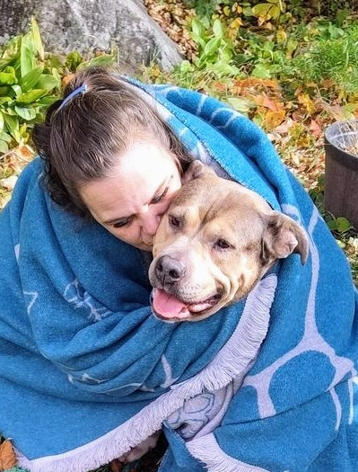This is my fur-baby, King. He was adopted only 2 years ago and now I can’t imagine not having him in my life. We enjoy camping, watersports, and taking road trips as often as possible. I bring my buddy with me where ever I can.

Sometimes, despite using a GPS, it can be challenging to locate dog parks in unfamiliar cities, making it difficult for us to enjoy our travels to the fullest.

But more importantly, because some law makers like to judge a book by it’s cover, we need to be careful of what areas we go to, because King could be considered a **‘vicious’** beast.

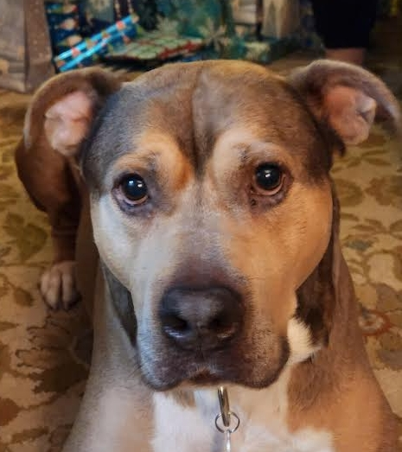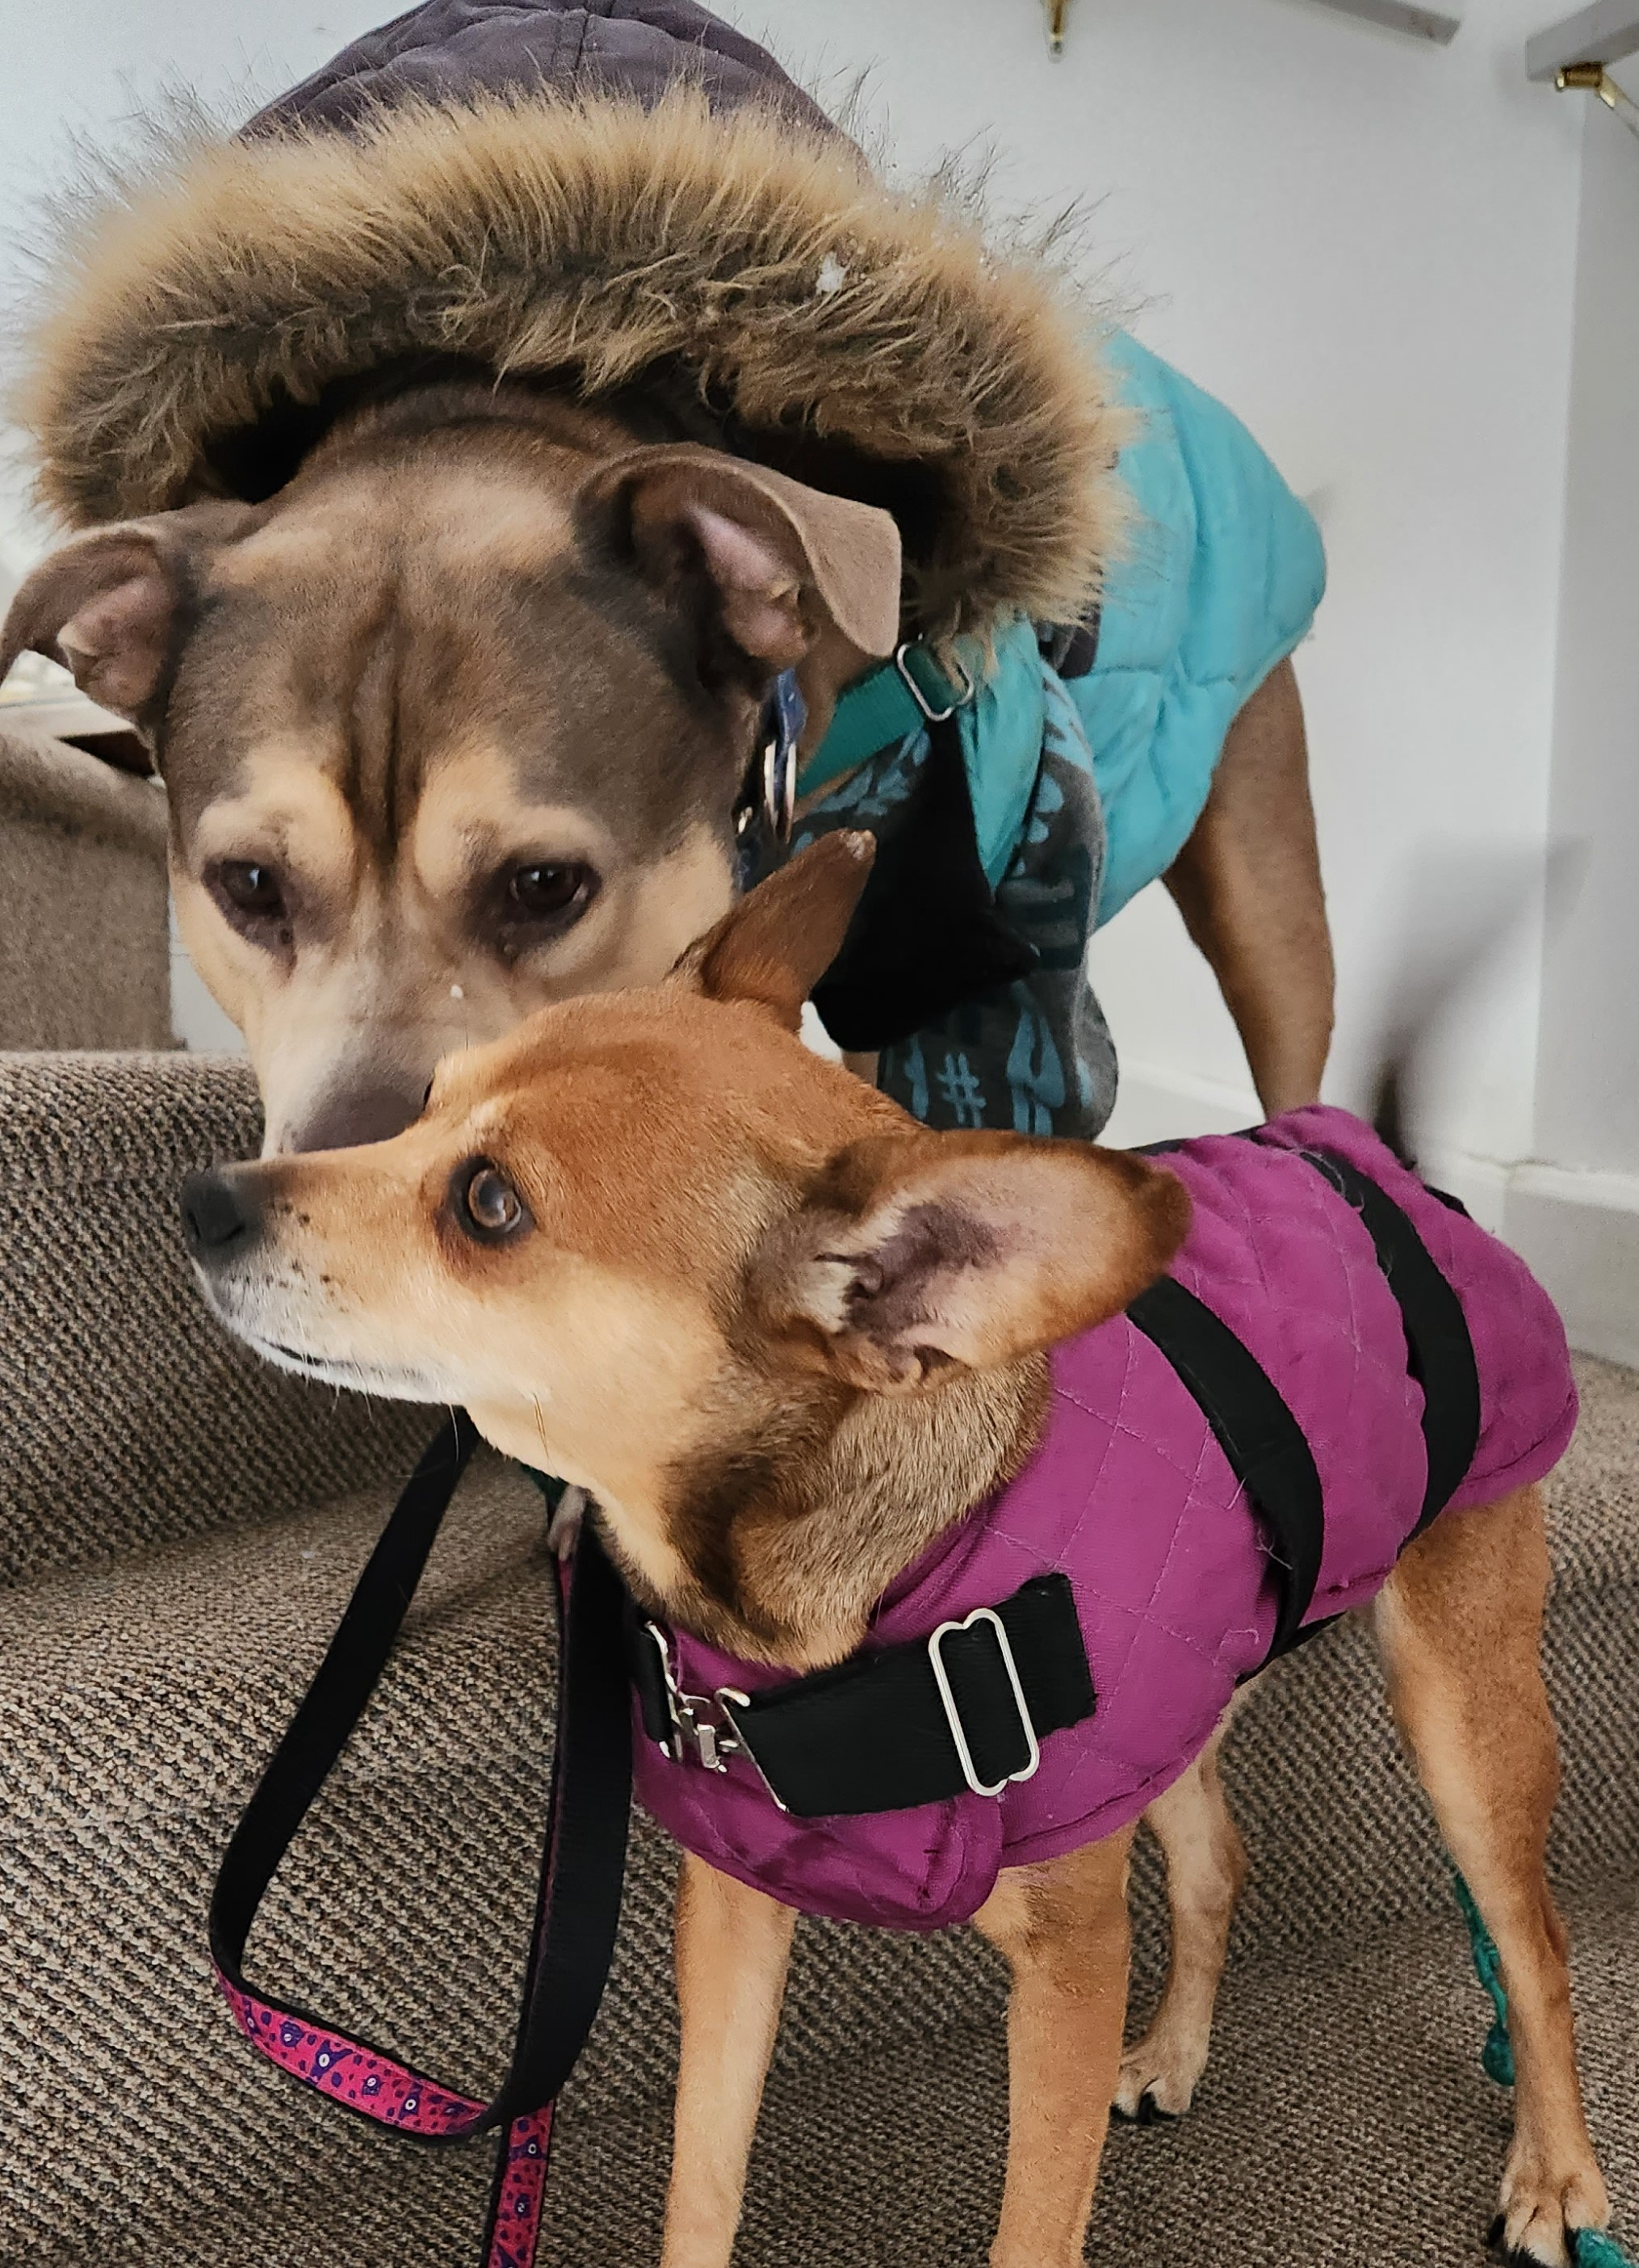

If they were to go to the wrong area, I could be fined, possibly jailed and worse of all, King could be apprehended and euthanized based solely on what he looks like. These laws are dependant on each jurisdiction, so each city or town could have their own definition of the law which makes it very confusing..

It would make their travels much easier if we could easily find local dog parks and know which areas to avoid due to BSL (Breed Specific Legislation).